**Experiment No : 2**

**Title:** Naïve Bayes for D & E Alphabet Classification

**Theory:**

I used Naïve Bayes Classification for multiclass learning here 3 and 2 classes respectively. Naïve Bayes classifiers store the training data, parameter values, data distribution, and prior probabilities

**Bayes Theorem :** Bayes' theorem describes the probability of an event based on prior knowledge (supervised) of conditions that might be related to the event.

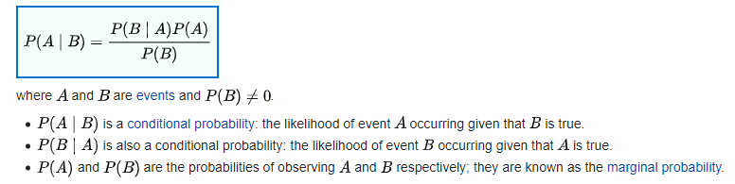

**Posterior Probability and Prior Probability -** A posterior probability is the probability of assigning observations to groups given the data like [P(A/B)]. A prior probability is the probability that an observation will fall into a group before you collect the data like [P(B)]

We Construct a Naive Bayes classifier for Fisher's iris & alphabet data

**Dataset used :**

Type of dataset (Isis, Alphabet)

For the second dataset(Alphabet csv 24 features files) we use character ‘d’ and ‘e at probability 0.50 each

Normalization have been performed of all the dataset i.e all values lie between 0-1.

**Characters in training dataset =** 50 samples

**Characters in testing dataset =** 50 samples

**Nr. of features used for character detection =** 24

Total 100 datapoints

We have 2 outputs i.e. class 0 and class 1

**CODE NR. 1 :**

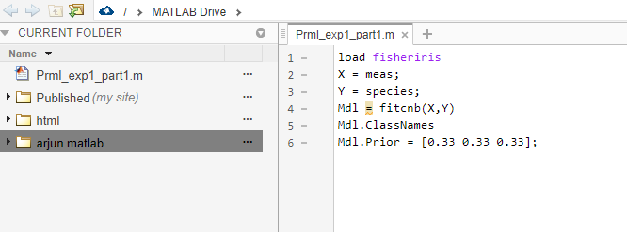

**OUTPUT NR. 1 :**

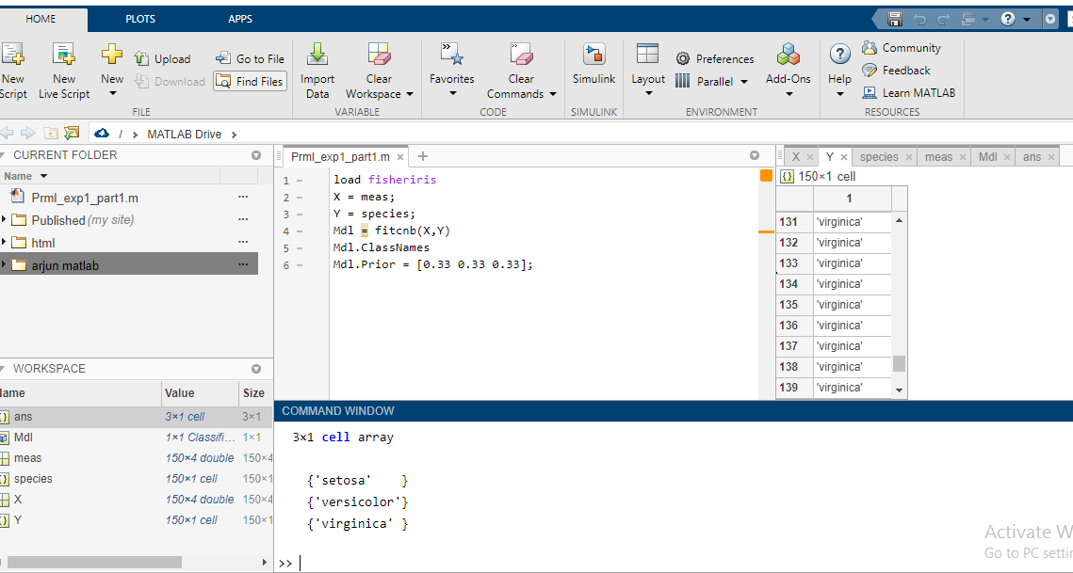

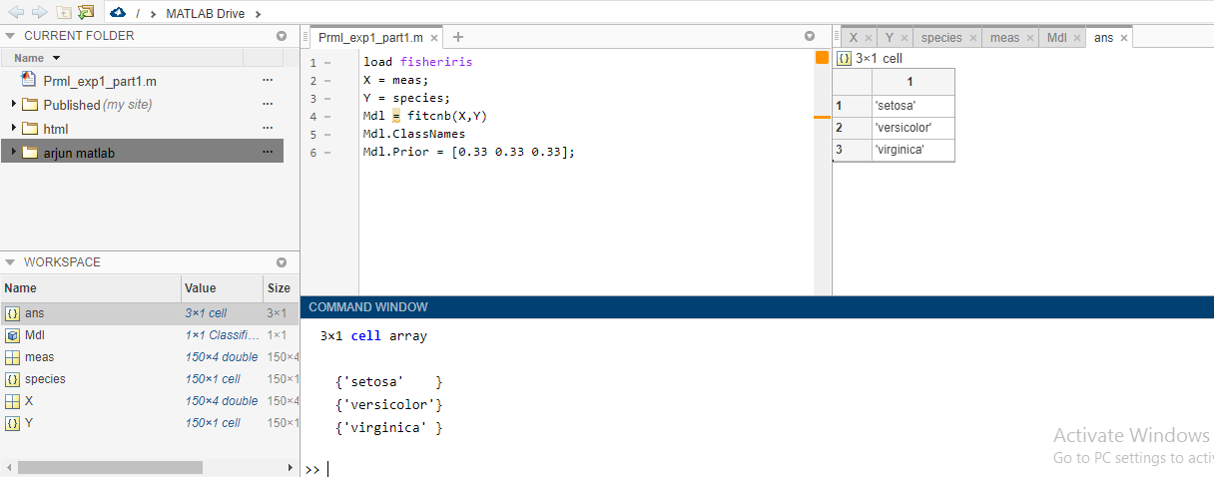

**CODE NR. 2 :**

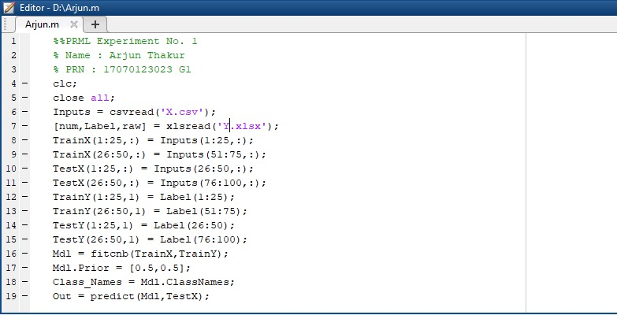

**OUTPUT NR.2 :**

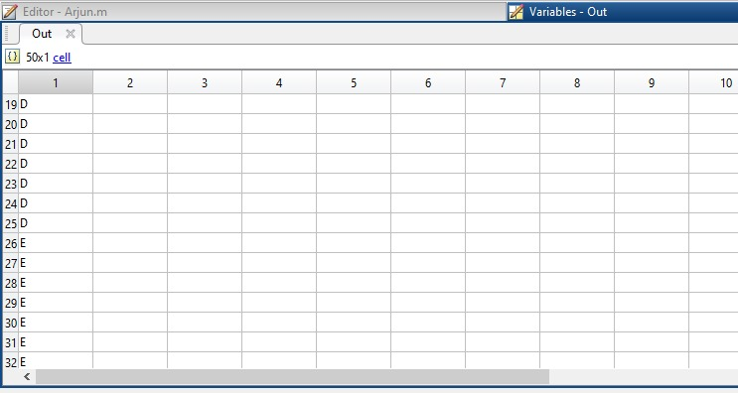

**Conclusion :** I got introduced to Bayes Theorem and how it is useful in Machine Learning. On change of prior probability the output y dataset ratio of both classification gets changed. I got a chance to work on Alphabet dataset and got introduced to CSV files too.